PROJECT DOCUMENTATION AND REPORT:

**LONG TERM INTERNSHIP ON SALESFORCE PROJECT TITLE : IMPLEMENTING CRMF FOR RESULT TRACKING OF A CANDIDATE WITH INTERNAL MARKE**

**INDUSTRY MENTOR: N.TARAKESH REDDY**

FACULTY MENTOR : K ANJANEYULY

TEAM ID : LTVIP2023TMID08743  **TEAM SIZE : 5**

**TEAM LEADER : GURALA DILLI PRASAD**

**TEAM MEMBERS: 1. VEMULA HARSHA VARDHAN**

**2. S VIVEK**

**3. MANDHUVA MADHURI**

**4. G NITHIN**

**IMPLEMENTING CRM FOR RESULT TRACKING OF A CANDIDATE WITH INTERNAL MARKS**

**Introduction :**

**Overview :**

The improved features of CRM software have increased both its complexity and necessity. Nearly half of CRM implementation campaigns suffer from improper preparation and misaligned objectives among internal stakeholders. A properly conceived CRM implementation strategy covers the breakdown of its goals, research, strategy, development, and future. This article is for small business owners who want to make sure they are taking the right steps when implementing a new CRM system.

**Purpose :**

The purpose of the project is to manage the school students result tracking process in the easy way. Students do not need to check the notice board and everyone will stay updated. This is the main purpose of this project. We can work easily and increase candidate quality. This project will also help to those professionals who are in cross-technology and wanted to switch to salesforce with the help of this project they will gain knowledge and can include into their resume as well.

**Literature survey :**

A CRM system can be used to improve the relationship you have with candidates. You can use it to communicate with them effectively, meaning they will be more likely to respond when you send them an email inviting them for an interview or informing them of their status in your recruitment process. Implementation of CRM in enterprises serves not only to maintain existing customers and acquire new ones but also introduces integration in the company, improves processes and communication between individual departments.

**Theoretical analysis :**

**Block Diagram : Diagrammatic view of the project :**

**Implementing CRM for result tracking of a candidate with internal marks :**

Create Salesforce Org – a) Creating Developer Org

b) Account Activation

⬇️

Object – Creation of semester object for candidate internal result card

⬇️

What is a Tab? – Creation of semester tab for candidate internal result card

⬇️

Lightning App – Create the candidate for internal result card app

⬇️

Fields and relationships – a) Creation of text field on lecturer details and look up field for the candidate object. b) Creation of auto number field on candidate object, number field on course details object and formula field course details object

⬇️

Users – Creating a User

⬇️

User Adoption – a) Create Record (Course details)

b) View Record (Course details)

c) Delete Record (Course details)

⬇️

Reports – a) Create Reports

b) View Reports

⬇️

Dashboards – a) Create Dashboards

b) View Dashboards

**Create a salesforce org** – We have created a developer org and activated the account.

Salesforce signup link : <https://developer.salesforce.com/signup>

Salesforce Login link : <https://login.salesforce.com>

In the below picture we have logged into Salesforce org.

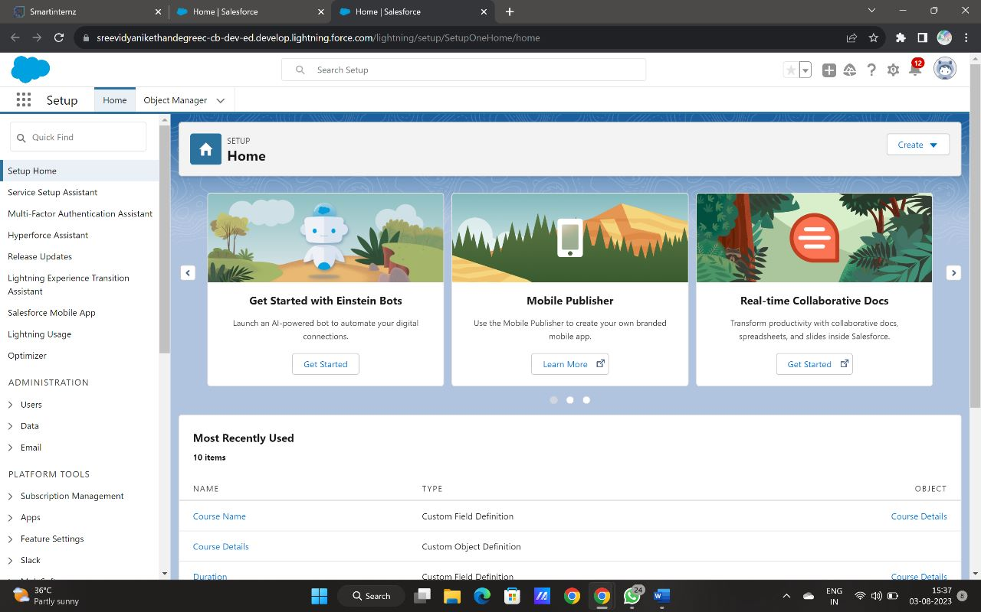

**Object** – We have created semester, candidate, course details, lecturer details, internal results object for candidate internal result card. In the same way we have created 4 more objects such as candidate, course details, lecturer details and internal results.

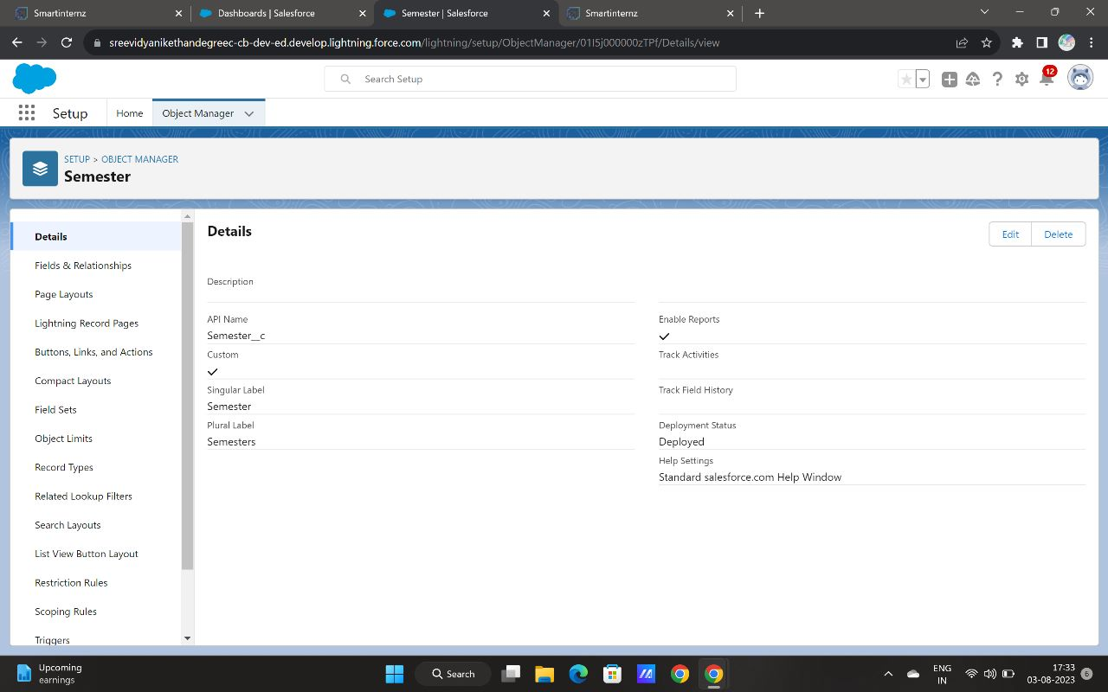

**Tab –** We have created semester, candidate, course details, lecturer details, internal results tabs for candidate internal result card.

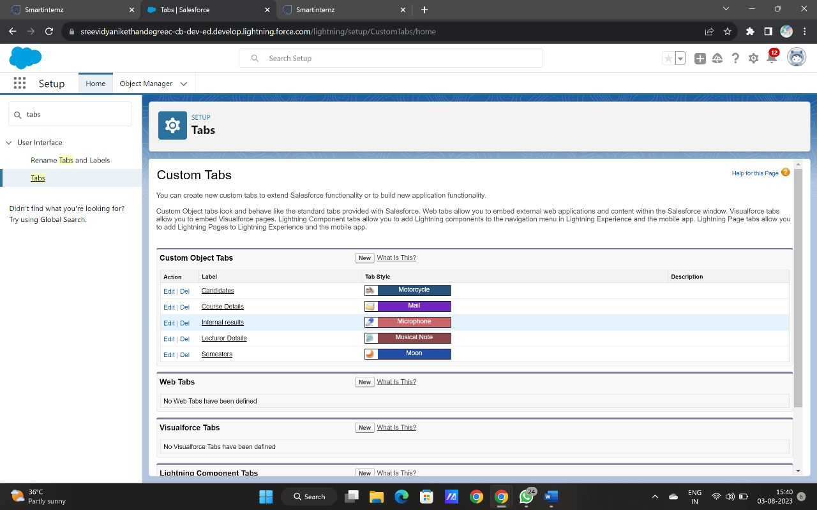

**Lightning App –** We have created the candidate internal result card app.

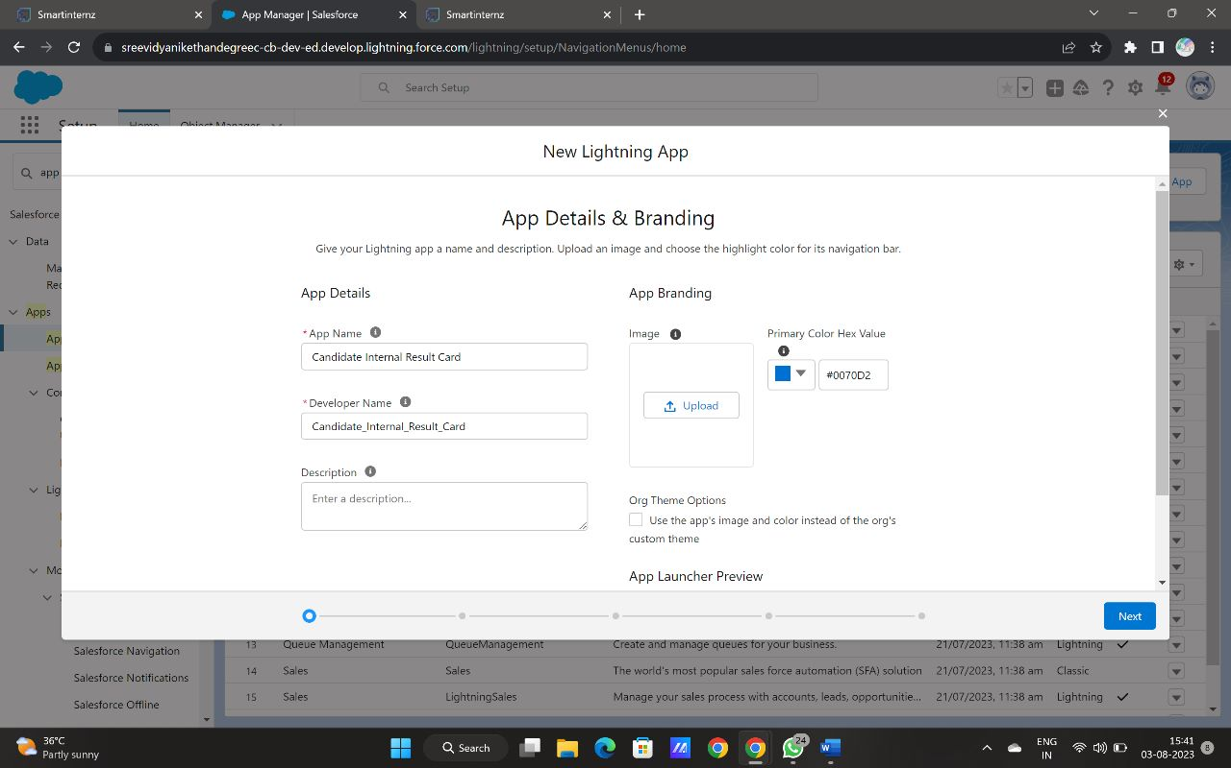

**Fields and relationships** – We have created text field on lecturer details and lookup field for the candidate object. And created auto number field on candidate object, number field on course details object and formula field course details object. In the similar way we have created all fields on their respective objects.

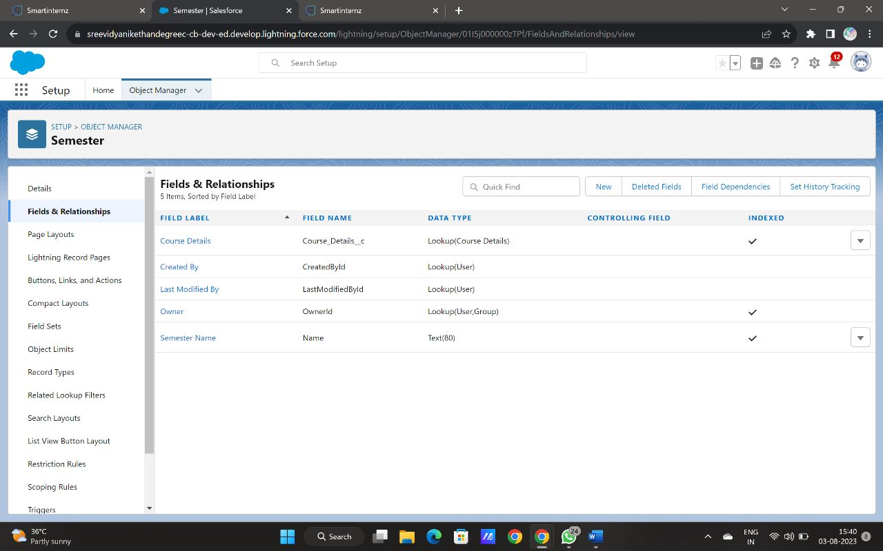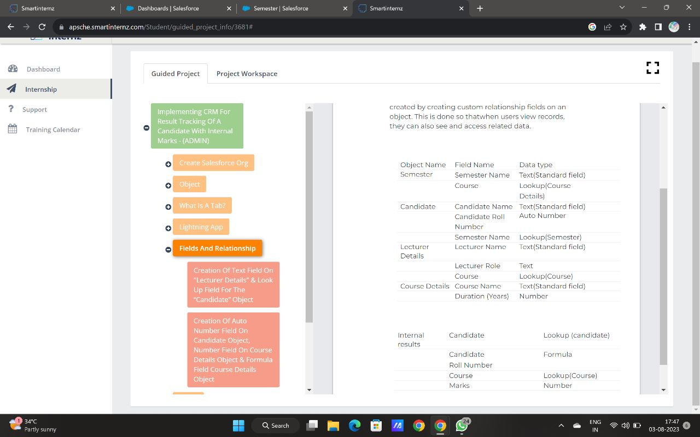

**Users** – We have created a user named as class teacher.

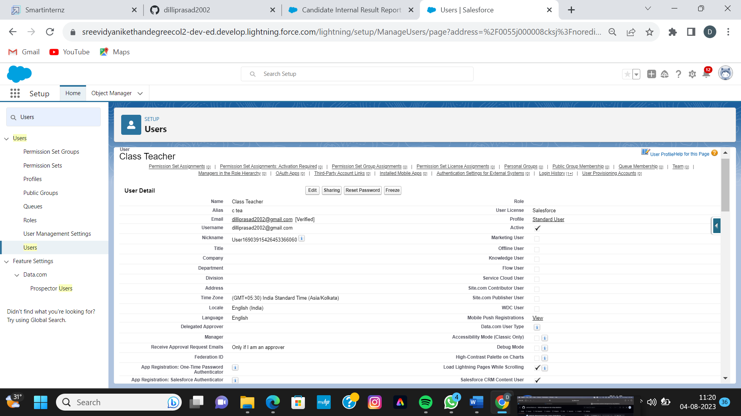

**User Adoption –** We have created records, viewed records and deleted a particular record in course details.

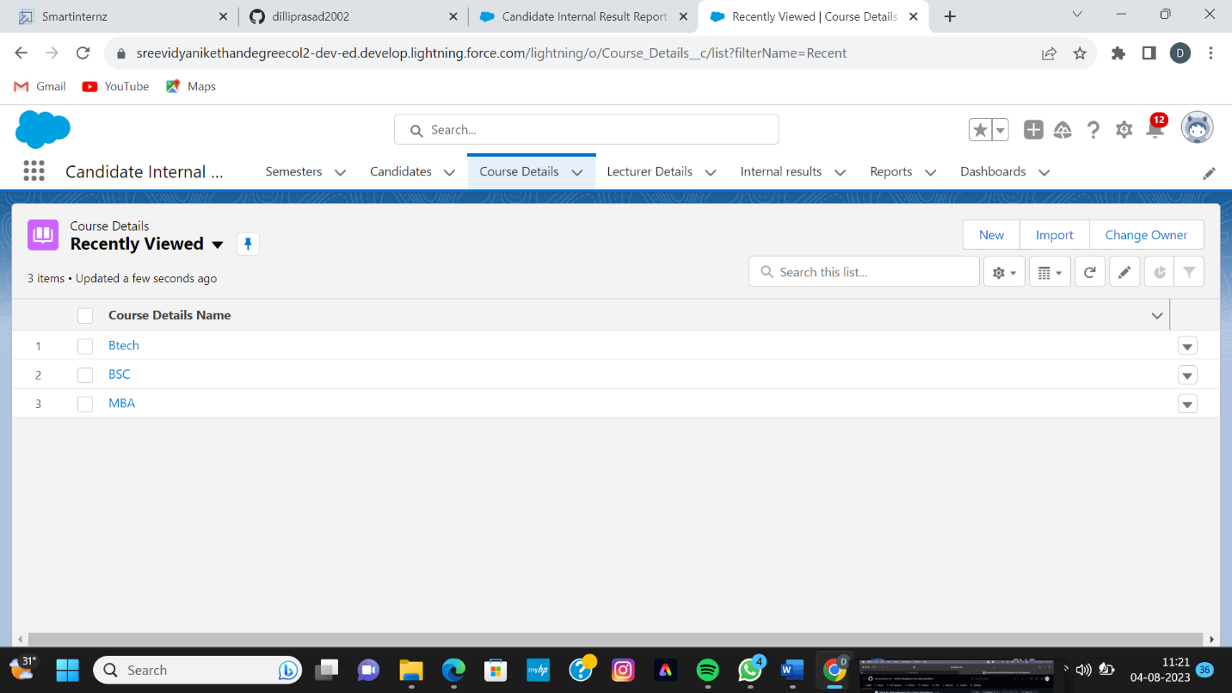

**Reports** – We have created and viewed report named as candidate internal result report.

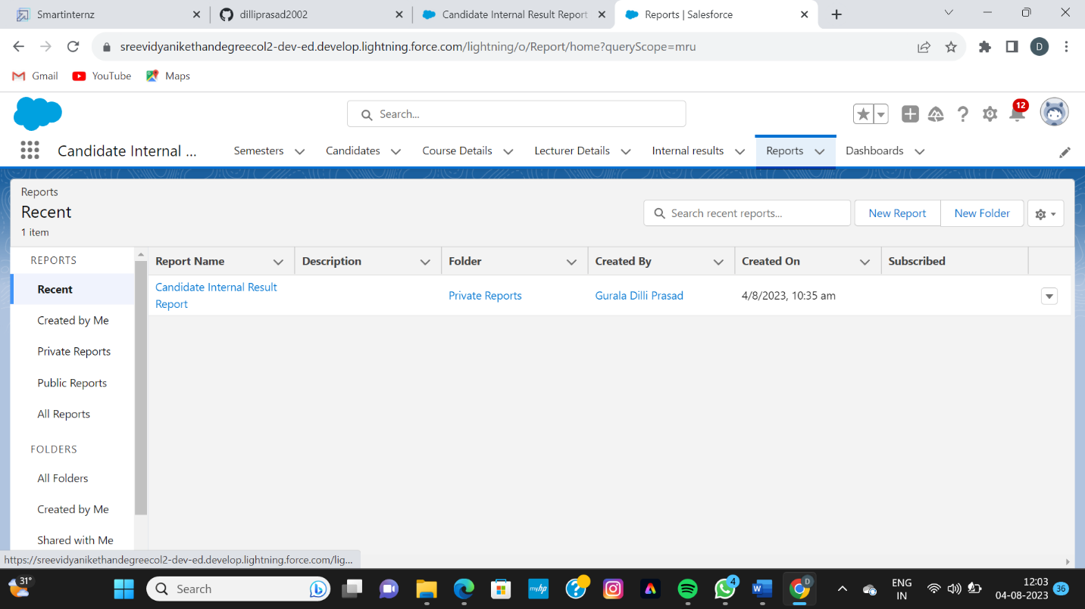

**Dashboards** – We have created and viewed dashboard named as candidate internal result card.

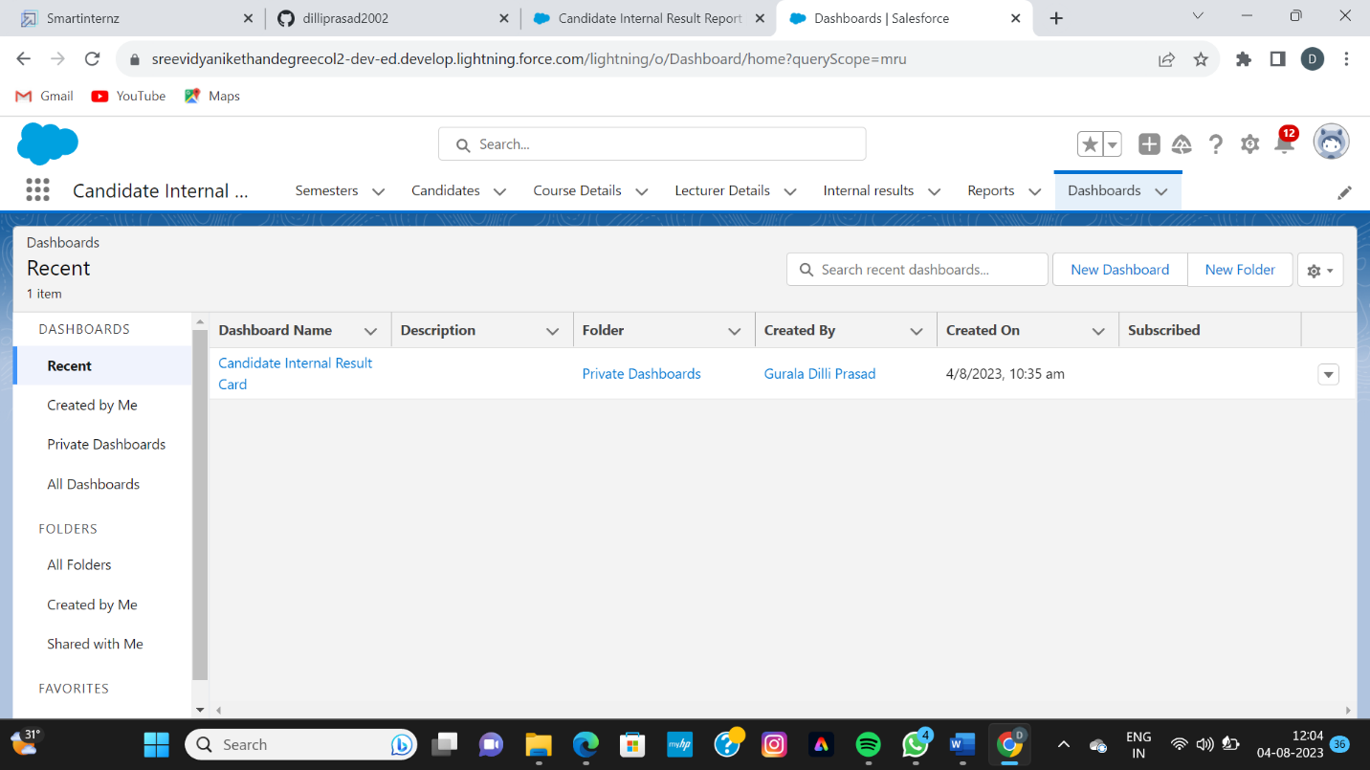

**Result :**

**Reports** – We have created and viewed report named as candidate internal result report. 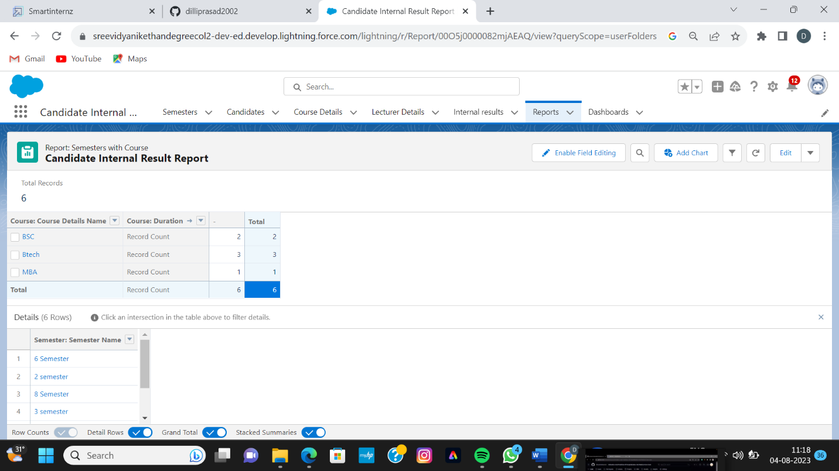

**Dashboards** – We have created and viewed dashboard named as candidate internal result card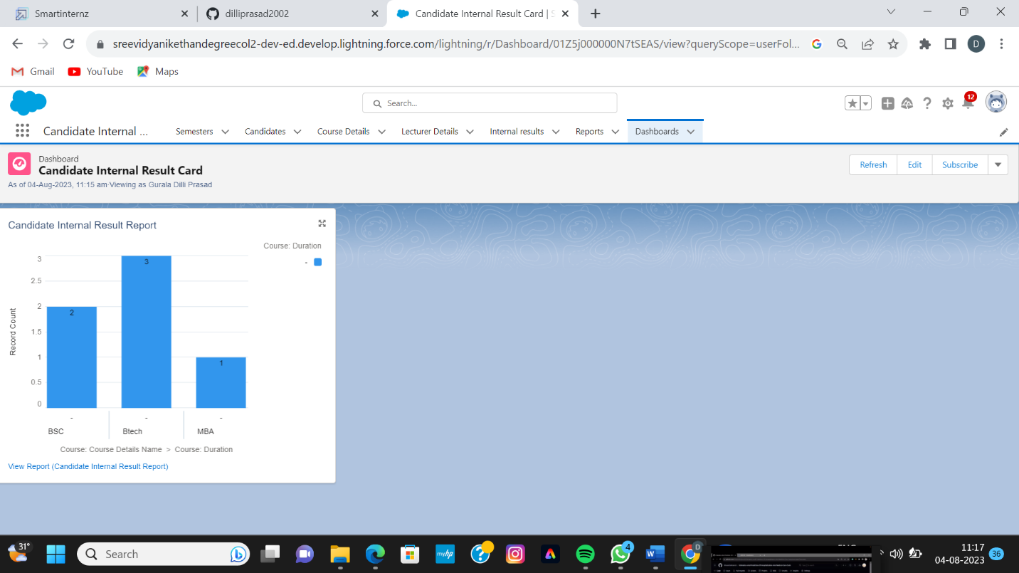

**Advantages and Disadvantages :**

**Advantages** :

* It allows for the consolidation of customer data and the basis for deep insights.
* It speeds up the sales conversion process.
* It increases staff productivity, lowering time-cost.
* It allows geographically dispersed teams to collaborate effectively.
* Improves Customer experience by allowing personalization and improved query resolution.

**Disadvantages** :

* Customer experience may worsen due to staff over-reliance on the system.
* Security and data protection issues with centralized data.
* The excess initial time and productivity cost at the implementation.
* Requires a process-driven sales organization.
* CRM may not suit all businesses.

**Applications** :

* Target marketing
* Increase candidate quality
* Can work easily
* Streamlining internal sales processes

**Conclusion :**

Student internal mark management system deals with student details, academic related reports, college details and course details. It tracks all the details of a student from the day one to the end of his/her course which can be used for all reporting purpose, tracking of progress in the course, completed semester, upcoming semester details, exam details, project or any other assignment details, and final exam result.

**Future scope :**

Scope of education means range of view, outlook, field or opportunity of activity, operation and application of education. Education has a wider meaning and application.